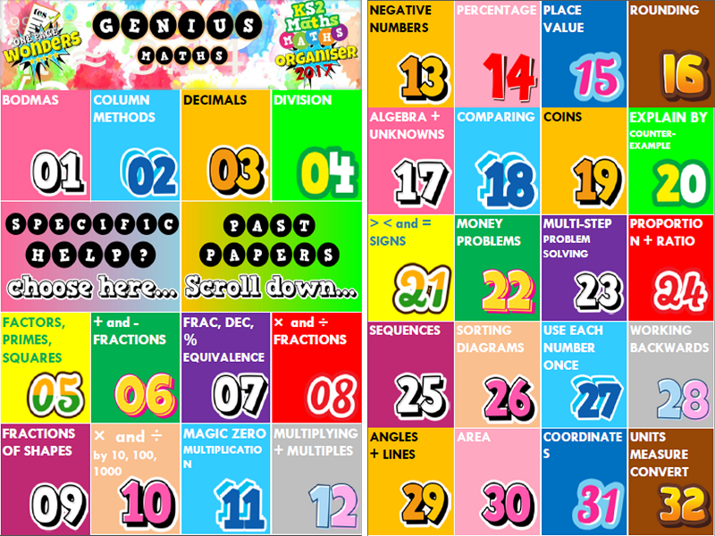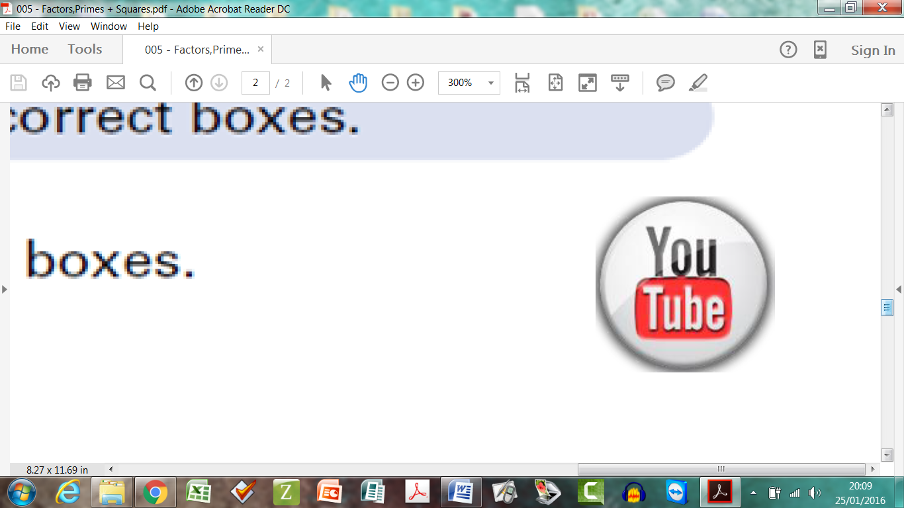

**Home Revision Schedule – To match work in school**

**Y6 Smash Your SATs !**

The revision schedule is designed to refresh memories on topics that may have been studies several weeks or months ago and to aid children with their exam technique. The list opposite does not necessarily correspond to what is being covered in class that week. Please watch the videos with your child if possible.

|  |  |
| --- | --- |
| Week Beginning… | Boosters to Focus on at Home |
| **Wk4 – 12th Mar** | 19 COINS |
| **Wk7 – Tue 17th Apr** | 20 COUNTER EXAMPLES |
| **Wk1 – 19th Feb** | 21< and > SIGNS |
| **Wk4 – 12th Mar** | 22 MONEY |
| **Wk6 – 26th Mar** | 23 PROBLEM SOLVING |
| **Wk4 – 12th Mar** | 24 PROPORTION RATIO |
| **Wk4 – 12th Mar** | 25 SEQUENCES |
| **Wk7 – Tue 17th Apr** | 26 SORTING DIAGRAMS |
| **Wk7 – Tue 17th Apr** | 28 WORK BACKWARDS |
| **Wk5 – 19th Mar** | 29 ANGLES + LINES |
| **Wk5 – 19th Mar** | 30 AREA |
| **Wk5 – 19th Mar** | 31 COORDINATES |
| **Wk4 – 12th Mar** | 32 UNITS AND MEASURES |
| **Wk5 – 19th Mar** | 35 PERIMETER |
| **Wk5 – 19th Mar** | 36 QUADRILATERALS |
| **Wk4 – 12th Mar** | 37 READING SCALES |
| **Wk4 – 12th Mar** | 41 TIME |
| **Wk5 – 19th Mar** | 42 TRANSLATE SHAPES |
| **Wk6 – 26th Mar** | 44-47 CHARTS + GRAPHS |
| **Wk6 – 26th Mar** | 48 THE MEAN |

Other Topics

**Wk1 – 19th Feb – Roman Numerals**

**Wk4 – 12th Mar – Mixed numbers (fractions)**

|  |  |
| --- | --- |
| Week Beginning… | Boosters to Focus on at Home |
| **Wk4 – 12th Mar** | 01 BODMAS |
| **Wk1 – 19th Feb**  **Wk2 – 26th Feb** | 02 COLUMN METHODS |
| **Wk1 – 19th Feb** | 03 DECIMALS |
| **Wk3 – 5th Mar** | 04 DIVISION |
| **Wk2 – 26th Feb** | 05 FACTORS, PRIMES |
| **Wk4 – 12th Mar** | 06 + and – FRACTIONS |
| **Wk3 – 5th Mar** | 07 FRAC DEC PERCS |
| **Wk4 – 12th Mar** | 08 × and ÷ FRACTIONS |
| **Wk4 – 12th Mar** | 09 FRACTIONS of SHAPE |
| **Wk2 – 26th Feb** | 10 × and ÷ 10, 100, 1000 |
| **Wk2 – 26th Feb** | 11 MAGIC ZERO |
| **Wk2 – 26th Feb** | 12 MULTIPLYING |
| **Wk1 – 19th Feb** | 13 NEGATIVE NUMBERS |
| **Wk3 – 5th Mar** | 14 PERCENTAGE |
| **Wk1 – 19th Feb** | 15 PLACE VALUE |
| **Wk1 – 19th Feb** | 16 ROUNDING |
| **Wk7 – Tue 17th Apr** | 17 UNKNOWNS |
| **Wk1 – 19th Feb** | 18 COMPARING |

Find the “***Maths KS2 SATs Buster”*** on the school website. Choose a specific topic to target a weakness or a past paper for mixed revision. All files can be printed out or streamed

**HIT** the **Youtube button** if you get stuck and watch the video explanation. Pause, rewind and watch again as many times as you like !